Sugar Grove Township Transportation Guide

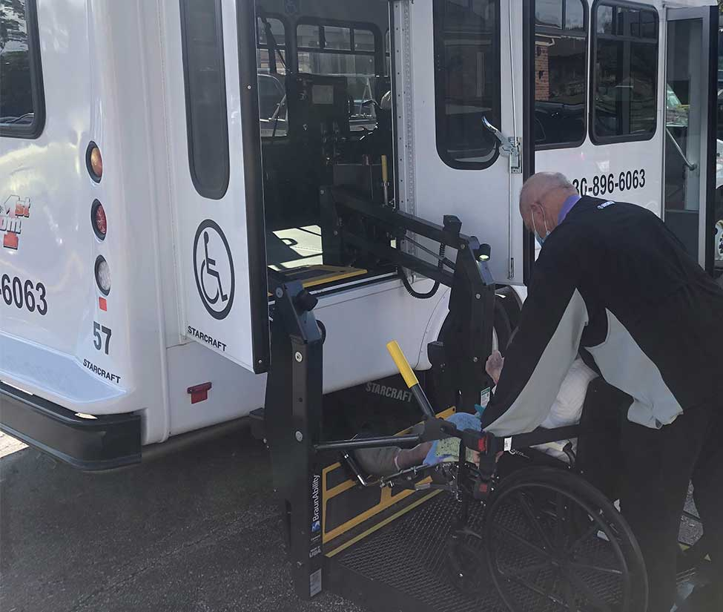

Sugar Grove Township offers public transportation service for resident individuals 65 and over or individuals with a disability 55 and over. Freedom First of North Aurora is the exclusive contractor for the township and provides handicapped-accessible vehicles.

Sugar Grove Township
P.O. Box 465, 54 Snow Street
Sugar Grove, Illinois 60554
(630) 466-4283
trowe@sgtownship.com

SUGAR GROVE TOWNSHIP SENIOR/DISABLED TRANSPORTATION RULES:

- Transportation is available Monday thru Friday from 7:30am-5:30pm excluding holidays

- Riders must be at least 65 years of age or disabled residents of Sugar Grove Township. Your physician needs to fax a letter to 630.466.5253 explaining what your disability is and why you need curb-to-curb service.

- Riders must have a driver’s license, State ID or valid passport to register for the program

- Disabled residents at least 55 years of age must be medically ineligible to obtain a State of Illinois driver’s license

- Transportation shall be provided for medical, employment and shopping purposes only

- Qualified persons are limited to 2 roundtrip rides or 4 one way rides per week for medical and employment purposes and 1 roundtrip or 2 one way rides per week for shopping purposes

- Transportation shall be provided only within the boundaries of Route 59 to the east, Route 30/34 to the south, Route 64 to the north, and Dugan Road to the west

- Riders will have a $5 co-pay each way for the first 10 miles and $1.50 per mile over 10 miles

- Once registered, riders must call 630-896-6063 at least 24 hours in advance to schedule a ride

- Rides are curb to curb so if you cannot get to the bus you will need a caregiver to help you

- One companion may accompany you in the vehicle free of charge

- For cancellations, changes & issues email rehab@freedomfirsttransportation.com or text 630-600-4646* per the following deadlines:
- Deadline of 6:00 p.m. the day before service for AM or All Day therapy
- Deadline of 9:00 a.m. the day of service for PM therapy
- Deadline of 2 hours prior to the end of your therapy session if you are canceling your return ride only

We are privileged to provide transportation services for residents of Sugar Grove Township attending appointments. Our goal is for your journey to be safe, timely, reliable and pleasant.

We’re looking forward to seeing you and ask that you complete this form prior to the start of your transportation services. There are 5 ways to provide the information to us:

- This is a fillable PDF form, you can complete it on your computer, tablet or smartphone without printing, save the file (but do not change the file name), then email it back as an attachment.
- Fax to 630-466-5253 or 630-409-3150
- Print, scan and email to trowe@sgtownship.com
- Complete the form, take a picture on a smartphone, and email to trowe@sgtownship.com
- Mail documents to Sugar Grove Township, P.O. Box 465, Sugar Grove, IL 60554
For questions or more information, call us at 630-466-4283 or 630-466-5255

Resident Name: __________________________________________________________ Male Female

Pickup Address: ____________________________________________________________________________________

City: ______________________________ State: _____ Zip: _________ County: __________

Home Phone: (________) ________________________ Cell Phone: (________) _______________________

Email Address: ________________________________________________________________________________________

Emergency Contact: ________________________ Phone: (_______) ______________ Relation: _____________

Date of Birth: _______/________/___________ Will patient travel with a companion: Yes No
(proof of age or disability is required)
Mobility status: Manual Wheelchair Power Wheelchair Scooter Ambulatory Ambulatory w/walker

Transportation: Roundtrip One-way inbound (home to appoint) One-way outbound (appoint to home)

Additional Notes: _____________________________________________________________________________

